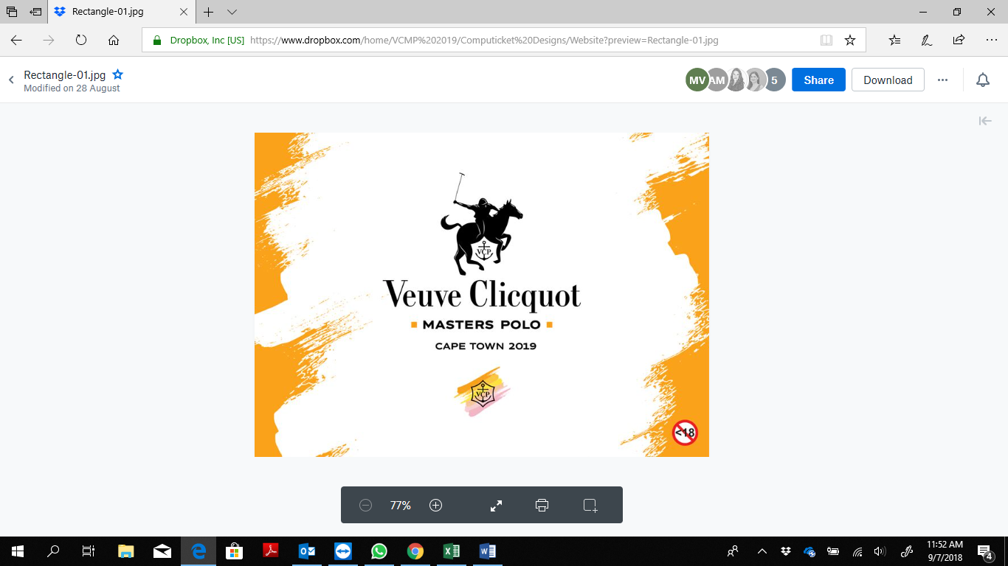

**VEUVE CLICQUOT MASTERS POLO CAPE TOWN 2019**

**The game, the champagne and the colour match!**

**JANUARY 2019.** The prestigious Veuve Clicquot Masters Polo Cape Town will return to Val de Vie Estate on 2 March 2019. Set against the spectacular backdrop of the Paarl-Franschhoek mountains, this stylish sporting and social event marks the peak of the South African polo season.

The ninth annual event, a highlight on the Western Cape calendar, will focus on the sport that has shown a sharp rise in popularity and skill in Africa over the past few years. It is expected that more than 3000 prestigious guests, many from neighbouring countries and provinces, will pay homage to the high-speed, high-skill game of polo while sipping Veuve Clicquot and celebrating summer. What’s new at the 2019 event is the extension of the VIP area where guests will have the opportunity to track the live polo match on oversized screens and remain engaged with the game.

Colour has always been at the heart of Veuve Clicquot and is a source of the champagne’s creativity and inspiration. It was in 1816 that Madame Clicquot developed the first riddling table designed to guarantee a crystal-clear wine and thus enhance the purity of colour of her champagne. She also created the first blended rosè in order to create a more intense colour and taste. This is the inspiration behind 2019’s “Colourama” theme that promises several artistic interpretations of the Veuve Clicquot heritage and a live fashion experience against the background of the game.

In line with Veuve Clicquot polo matches in New York and Los Angeles, the spotlight is on understated but elegant daywear in chic colour blocking ranging from sunburst yellow to blush-pink. Guests are encouraged to wear comfortable shoes for the much-anticipated divot-stomping during half time of the polo match. This year ‘Best Dressed’ falls away, conforming with the international celebration of polo with focus on the game, social and business networking and the Veuve Clicquot lifestyle experience. The day will also begin earlier to allow guests to make their way to after-party venues in surrounding towns.

Renowned as one of the best polo events in the world, the 2019 Veuve Clicquot Masters Polo will be attended by influencers, thought-leaders and VIPs from across the African Continent.

**EVENT DETAILS**

Date: Saturday 2 March 2019

Time: 2pm to 7pm

Venue: Val de Vie Estate (Paarl-Franschhoek Valley)

Theme: Colourama

Hashtag: #vcmasterspolo

NB: This event is not open to persons under the age of 18 years

Tickets: [https://online.computicket.com/web/event/veuve_clicquot_masters_polo_2019/1248481504/0/89155005](https://protect-za.mimecast.com/s/HH1-Cmw0l5fG5PjHGYJEU?domain=online.computicket.com)or for lounge bookings email [hospitality@vcmasterspolo.co.za](mailto:hospitality@vcmasterspolo.co.za)

**TICKET OPTIONS**

**Veuve Clicquot VIP: R4300 per person\***  
Ticket includes Veuve Clicquot Yellow Label as your signature drink for the day, a VIP hospitality lounge experience with luxurious seating, VIP canapé service and gourmet grazing tables, premium Veuve Clicquot Bars with a Private Butler Service, VIP Entry and parking, and a premium view of the polo pitch with full security.  
  
**Clicquot Garden: R1300 per person\***  
Ticket includes access to the Clicquot Garden lounge area on the lawn including seating facilities, one glass of Veuve Clicquot Yellow Label per person, a lunch menu and panoramic views of the polo field and fashion show. A cash bar will be available including the sale of Veuve Clicquot by the glass or bottle at a special event price.  
  
**Clicquot Picnic: R380 per person\***  
Ticket includes access to the picnic area. A cash bar is available including the sale of Veuve Clicquot by the glass or bottle at a special event price. Gourmet Food Trucks will also be available.   
No food or drink may be brought onto the estate.

*All prices are inclusive of VAT

**MEDIA**

For additional event information, still images and footage, or to arrange an interview with participating Veuve Clicquot Masters Polo representatives, please contact [media@vcmasterspolo.co.za](mailto:media@vcmasterspolo.co.za)

ENDS

**FOR FURTHER PRESS INFORMATION PLEASE CONTACT:**

Email: [media@vcmasterspolo.co.za](mailto:media@vcmasterspolo.co.za)

Tel: +27 (0) 21 867 8000

[www.vcmasterspolo.co.za](http://www.vcmasterspolo.co.za)